# Why this playbook

hi

I am amuldotexe

[twitter.com/amuldotexe](http://twitter.com/amuldotexe)

this playbook has some notes which I have assimilated from over last 13 years of my journey in tech

[tl;dr of my journey can be read here](https://twitter.com/amuldotexe/status/1704662554172371094)

I wrote this playbook for 3 people

* for my future self, to reflect on my methods
* for my friends so I can point them to my notes at one place
* for my potential collaborators, so I can give them a taste of my thought process

I hope you enjoy reading this playbook as much as I enjoyed writing it

and if

some of what I write vibes with you

please do reach out via DMs

to tell me about it

[this link](https://twitter.com/messages/compose?recipient_id=1132151165410455552&text=Hello%20world) directly opens a twitter conversation with me

p.s.

just to be explicit, this playbook is free, that is you are free to

* copy it to your google drive or share it in its entirety via any medium
* share text or screenshots from it

# Relevant for some, not for everyone

Rule 0:

Context is everything

everything I share here is a hypothesis

I could be wrong

because your context

might be wildly different

I am not a creator, teacher, mentor, advisor, expert etc.

I am merely a practitioner

sharing his notes

my methods are not comprehensive

they are rooted in

my biases

my angels

my demons

my strengths

my weaknesses

and

my privileges

so these notes are

relevant for some

not for everyone

# Table of Contents

Why this playbook

Relevant for some, not for everyone

Table of Contents

Section 1: Twitter Threads, Miro Boards & GSheets

Chapter 1: Designing your life

1.1 Long term decision making frameworks

1.1.1 Default Generic Decision Making framework

1.1.2 Evidential & experiential parameters

1.1.3 Creating your multiverse

1.1.4 Learn to gamify experiences via Self Determination Theory

1.2 Frameworks for Parenting in India

1.2.1 Kids with age ~ 10 years

1.2.2 Engineering entrance exam prep game in India

1.3 Trade-offs

1.3.1 India vs EU for top 5% devs

1.3.2 Working at zero to 1 places

1.4 Choosing a career path

1.4.1 PM vs IC Dev

1.4.2 Why not Data Science

Chapter 2: Job Search

2.1 How to initiate job search

2.1.1 Company classification framework

2.1.2 List of 4 thousand companies across EU SEA India classified by funding amount

2.2 How to get shortlisted

2.2.1 Visual CV which differentiates you

2.2.2 Proof of work docs: SOPs & case studies of B2C apps you shipped

2.3 Interview Games

2.3.1 How to speak in interviews

2.3.2 Salary Negotiation

2.4 Selling the idea of You

2.4.1 How to be discovered on twitter

2.4.2 How to post on social media

Chapter 3: Low Drama Hypotheses

3.1 Low drama Standard Operating Procedures

3.1.1 Seven hypotheses for a developer in India

3.1.2 Navigating a recession

3.1.3 Low Risk Dev Career Roadmap

3.1.4 SOP to manage your tasks

3.2 Managing Anxiety

3.2.1 Notes from ADHD Subreddit

3.2.2 Managing your time

3.2.3 Most procrastination is drama & fear

3.2.4 Slow down time to make better decisions

3.3 The utility of acceptance

3.3.1 Be ready with a job loss simulation

3.3.2 When you realize you will not achieve FIRE

Chapter 4: Compounding

4.1 Building the intuition for compounding

4.1.1 How money grows at different CAGR

4.1.2 Minimalist retirement planning tool

4.2 How different financial instruments compound in India

4.2.1 Endowment Policy vs FD/Debt Fund vs N50

4.2.2 Nifty Index hands-on analysis 2010 to 2018

4.3 How being good at math helps

4.3.1 Learn math to be a better decision maker

4.3.2 Learn math to avoid -ve spirals

Section 99: What next

99.1 Playbook release cadence

99.2 Topics for next release

# 

# 

# 

# 

# 

# 

# 

# Section 1: Twitter Threads, Miro Boards & GSheets

Some of my tweets, miro boards & google sheets that vibed hard on my twitter account classified by themes

## Chapter 1: Designing your life

### 

### 1.1 Long term decision making frameworks

#### 

#### 1.1.1 Default Generic Decision Making framework

When to use it:

When the decision you are taking isn’t time critical & will have long term impact on your life

How to use it:

Follow the steps mentioned for taking the decision, but before that think hard on why those steps were thought of, so you can build conviction on the steps

PDF link: [_VN Long term decisions framework.pdf](https://drive.google.com/open?id=130rvOA8h6ML2EX20AF9_avs_KWF_mO56)

Miro link: [Miro frame](https://miro.com/app/board/uXjVNy-rxfI=/?moveToWidget=3458764583940330473&cot=14)

#### 

#### 1.1.2 Evidential & experiential parameters

When to use it:

When you are trying to evaluate the possible impact of a long term goal on your life in terms of metrics. Often we can be tunnel visioned in our thinking of how we measure life, this note helps broaden that vision

How to use it:

Read about self-determination theory for 2 minutes so you can understand the framework better

PDF link: [_VN Evidential & Experiential Parameters.pdf](https://drive.google.com/open?id=1W-a-wVr0jWiuShdYSz5Sqm0ZKSxAqKSQ)

Miro link: [Miro frame](https://miro.com/app/board/uXjVNy-rxfI=/?moveToWidget=3458764577679689386&cot=14)

#### 1.1.3 Creating your multiverse

When to use it:

When you are trying to design your life for a 5 year or 10 year time frame

How to use it:

The multiverse framework helps you think of career design as a subset of life design & nudges you to think of your futures as possibilities rather than one single timeline. If you can do the tedious work of thinking through the simulations, it can be immensely rewarding in giving you clarity, peace & courage

Link : [Twitter thread](https://twitter.com/amuldotexe/status/1584431929457184768)

#### 

#### 1.1.4 Learn to gamify experiences via Self Determination Theory

When to use it:

When you are trying to design any experience for yourself or for your customers or stakeholders or any ecosystem

How to use it:

This cheat-sheet helps you hold the essence of Self Determination Theory in your RAM so you can notice it in action in all the experiences being created around you

This sheet covers 60% of all long term gamification you will ever need to learn

Maybe the first person to experiment this on is yourself to improve your own productivity

PDF link: [_VN Gamification Self Determination Theory.pdf](https://drive.google.com/open?id=18JVbgWEOhUtcFsS9l8kQzzhqPCIn_BUx)

Miro link: [Miro frame](https://miro.com/app/board/uXjVNy-rxfI=/?moveToWidget=3458764577680256005&cot=14)

### 1.2 Frameworks for Parenting in India

#### 

#### 1.2.1 Kids with age ~ 10 years

When to use it:

If you are in India & your kid is ~ 10 years of age & trying to decide what parts of curriculum to focus on for long term career games in India

How to use it:

Re-read this thread every month to build & recharge conviction on why you will need to make trade-offs on what is really important for your kid to help them survive the Indian career game in a graceful manner

Link : [Twitter Thread](https://twitter.com/amuldotexe/status/1602195464597618688)

#### 

#### 1.2.2 Engineering entrance exam prep game in India

When to use it:

If you are in india & are positive that you want your kids to pursue engineering entrance exams / math related competitive exams after class XIIth

How to use it:

Realize that this is going to be a tough journey and you can make it less intense by starting early with focus on problem solving skills rather than other subjects, thus leading to cumulative advantages over the cohort you are competing with

Link : [Twitter thread](https://twitter.com/amuldotexe/status/1602647393467506689)

### 

### 

### 1.3 Trade-offs

#### 

#### 1.3.1 India vs EU for top 5% devs

When to use it:

When as a top 5% dev you are trying to evaluate whether you should move to EU or stay in India

How to use it:  
The comparison is biased by my exposure to a certain sample of folks, so take it with a pinch of salt. But more importantly it gives you a list of parameters to consider to evaluate this decision more rigorously

#### 

PDF link : [_VN Trade Offs India vs EU 202403.pdf](https://drive.google.com/open?id=1laipUu1bHmi_iLETRX2xJ3fEAyff4z4W)

Miro link: [Miro frame](https://miro.com/app/board/uXjVNy-rxfI=/?moveToWidget=3458764577696624038&cot=14)

#### 

#### 1.3.2 Working at zero to 1 places

When to use it:

When you feel the nudge to join an early stage company even if you have the capability or options to have a stint at a more recognizable, better long term brand-name company

How to use it:  
The note is biased by a core assumption that 90% of your next job shortlisting by a recruiter or a hiring manager is highly biased by recognizable company brand-names, hence your main job is to compile high quality recognizable brand-names early in your career

Link: [Twitter thread](https://twitter.com/amuldotexe/status/1738243872231428484)

### 1.4 Choosing a career path

#### 

#### 1.4.1 PM vs IC Dev

When to use it:

When you are wondering if you should go into the path of being a pure individual contributor or should take some kind of planning job like product management or Engineering Management etc.

How to use it:

The evaluations are biased by my experience & hence should be taken with pinch of salt

PDF link: [_VN PM vs Dev 202401.pdf](https://drive.google.com/open?id=1T9rw9kOAULWXJ4mDEdDQGpefKrsvWUHI)

Miro link: [Miro frame](https://miro.com/app/board/uXjVNy-rxfI=/?moveToWidget=3458764577699177065&cot=14)

#### 

#### 1.4.2 Why not Data Science

When to use it:

When you feel the nudge to pursue a career in Data Science in India due to the fomo around you or all the advertisements around you

How to use it:

More than the evaluation, look at which parameters are thought of while analyzing Data Science as a field, hopefully they make your own analysis a bit more rigorous, thus helping you build conviction irrespective of whether you choose to pursue it or not

Link: [Twitter Thread](https://twitter.com/amuldotexe/status/1751482951781740795)

## Chapter 2: Job Search

### 2.1 How to initiate job search

#### 2.1.1 Company classification framework

When to use it:

Whenever you want to understand how many different types of companies employ in India & what would be the ways to list them

How to use it:

Understand that getting names of companies is a non-trivial exercise, especially because so many people just apply to companies they have heard of thus falling for availability bias. This is the key reason people keep suffering through job switches because they never pause to deliberately think about this problem and never discover some niche high quality companies which are more suited to their needs

There are always some small pockets of high quality companies which people do not know about because they aren’t popular on social media circles

Creating your own list from first principles taking ideas from this framework will likely help you discover such under-rated companies

PDF link: [_VN Company list ideation.pdf](https://drive.google.com/open?id=1neKlvRyyPMeNdW7C2HNbiy3BDuqHyg_w)

Miro link: [Miro Frame](https://miro.com/app/board/uXjVNy-rxfI=/?moveToWidget=3458764577700118338&cot=14)

#### 2.1.2 List of 4 thousand companies across EU SEA India classified by funding amount

When to use:

When you have started your job search & now want to start applying with full vigor

How to use it:

* Identify segment of companies & priority order of companies based on decreasing funding amount or location or any other parameter
* Apply via following routes in decreasing order of priority
  + Find a personal IRL connect who can refer or Find a social media connect who can refer
  + Apply on job portals, the more native to that geography the better, i.e. prefer a local job search portal over Linkedin, so you are part of a smaller cohort of applicants

Google Sheet Links

* [Indian companies with funding < $50MM](https://docs.google.com/spreadsheets/u/0/d/1rgdQYn8h1Up8uyAm-cAvTMG2DylLf0flUgcdfsgH-eg/edit)
* [SEA companies with funding < $50MM](https://docs.google.com/spreadsheets/u/0/d/1mpltJCbPChWntsjg2DC8HBQGLF7RamjCtFFnuDniLrY/edit)
* [EU companies with funding < $50MM](https://docs.google.com/spreadsheets/u/0/d/1O1wm0oWSRJ-ycRzcO949SVoTgMEgAt7a1YhFBIMkw-M/edit)
* [Indian companies with funding >= $50MM](https://docs.google.com/spreadsheets/u/0/d/1thyNbD_UNVEtf1vdHlVlf-CwpxsBCq0lBgbVv68GGZU/edit)
* [SEA companies with funding >= $50MM](https://docs.google.com/spreadsheets/u/0/d/1R8iPQDagcrHqdYfrjPr1ZL8PFbIr_p3veq8cP7ip6Po/edit)
* [EU companies with funding >= $50MM](https://docs.google.com/spreadsheets/u/0/d/1f-0TxZRyU9mAQA8CxS83DRqbWsqTNIv5lTM8y_ImoP8/edit)
* [Data Science companies in India](https://docs.google.com/spreadsheets/u/0/d/1s5Y9Qy_xicngHWCHXJXhhb_iHi5BdhlgnK7IOvQSo9o/edit)
* [EU Game Dev companies](https://docs.google.com/spreadsheets/u/0/d/1KsT4gjeWMZE27uV_0UD6AQtYyePTOEEwfCGNhCHY3kE/edit)

### 2.2 How to get shortlisted

#### 

#### 2.2.1 Visual CV which differentiates you

When to use:  
When you want to experiment with your shortlisting chances by trying something more creative than a standardized CV

How to use:

The pdf version of the below experimental CV can give you following ideas

* How to present a CV as a narrative
* How to highlight your company logos better
* How to use visual elements to express your creative side

PDF link : [_Bookmark amuldotexe example visual CV.pdf](https://drive.google.com/open?id=1yBNb0yzenje8z-92u7yg10mvczs4lVtW)

#### 2.2.2 Proof of work docs: SOPs & case studies of B2C apps you shipped

When to use:  
When you want to use extra documents beyond your CV to differentiate yourself from other candidates

How to use:  
Pick ideas from the 2 docs to impress the hiring manager or recruiter with the notion that you have some interesting unique insights that could be relevant to them & you made the extra effort to compile them for their perusal

* B2C Feature launch SOP:  
   [_Bookmark amuldotexe feature launch SOP.pdf](https://drive.google.com/open?id=1G0V2HreWO0ze5dyJrQ2RZDVyLFJxfHdQ)
* Narrative of a game/app your worked on: [_Bookmark amuldotexe game showcase Monopoly Slots.pdf](https://drive.google.com/open?id=1PkQKoJbhQDusP5qSyidXrtGaAZrvlxI8)

### 2.3 Interview Games

#### 

#### 2.3.1 How to speak in interviews

When to use:

When you want to improve your performance in job interviews via the way your present your thoughts or communicate

How to use it:

While the methods can be applied by simply being aware of them during interviews, they work better if you imbibe them via daily practice. What’s more these methods will also make you a better collaborative problem solver

Link: [Twitter thread](https://twitter.com/amuldotexe/status/1711092018397741434)

#### 2.3.2 Salary Negotiation

When to use:

Ideally the moment you start your job search, you should revisit this standard operating procedure & pick ideas to plan you path ahead

How to use:

The method is biased by my experience as a candidate, so take it with a pinch of salt, but I’d ask you to pay attention to the steps mentioned & think of the meta idea, as to why that step was included in this standard operating procedure. Maybe some of those meta patterns might be useful in your gameplay

PDF link: [_VN Salary Negotiation.pdf](https://drive.google.com/open?id=1uHeR0CbuiWjwrg59LgypgwTib4V3P9vW)

Miro link: [Miro frame](https://miro.com/app/board/uXjVNy-rxfI=/?moveToWidget=3458764577779081661&cot=14)

### 

### 2.4 Selling the idea of You

#### 

#### 2.4.1 How to be discovered on twitter

When to use:

When you want to network better on twitter & be discovered by your tribe

How to use:

Rigorously think through & validate this diagram from your own experience of using twitter. You may realize how a lot of HQ twitter is not about being the main character but by being the reply person who genuinely engages with high quality content

PDF link: [_VN How to be discovered on twitter.pdf](https://drive.google.com/open?id=1MTfsJ5x693W3LuVqTWN6nJPdDRZsFv4i)

Miro link: [Miro frame](https://miro.com/app/board/uXjVNy-rxfI=/?moveToWidget=3458764577677802701&cot=14)

#### 2.4.2 How to post on social media

When to use:

Whenever you are planning to make a social media profile or re-evaluating your presence on social media with certain objectives in terms of branding or networking

How to use:  
This visual note is a way to think of your social media presence as a product experience you are creating for those who are exposed to your profile, thus helping you identify levers which can help you achieve certain desired objectives from your time spent

PDF link: [_VN How to design your twitter account as an experience.pdf](https://drive.google.com/open?id=1s6Lz2KEjHowtTLy9f8EiXxi54Dw8_8Yk)

Miro link: [Miro frame](https://miro.com/app/board/uXjVNy-rxfI=/?moveToWidget=3458764577676729977&cot=14)

## 

## Chapter 3: Low Drama Hypotheses

### 3.1 Low drama Standard Operating Procedures

#### 3.1.1 Seven hypotheses for a developer in India

When to use: When your salary as a dev in India is <= Rs 20 l.p.a

How to use: This is the essence of what I share with all early career folks I meet anywhere, especially try to identify the meta-pattern for the hypotheses, see if they are relevant for you

Link: [Twitter Thread](https://twitter.com/amuldotexe/status/1676125636887449600)

#### 3.1.2 Navigating a recession

When to use:

When the demand for tech talent is low & you feel unsure how to navigate it

How to use:

Go through the steps outlined & try to think how this Standard Operating Procedure focuses not only on idea of making money but also how to gracefully steer through a bear cycle

Please pay attention to the meta pattern of risk management which is the core thesis for this document & how risk management actually helps you have more courage + peace during odd times

PDF link: [Visual Notes 2024 - Navigating a recession.pdf](https://drive.google.com/file/d/15O0Q9R0z1ESV1P2Qb9G4RYrRiXECC7mS/view?usp=drive_link)

Miro link: [Miro frame](https://miro.com/app/board/uXjVNy-rxfI=/?moveToWidget=3458764577619995409&cot=14)

#### 3.1.3 Low Risk Dev Career Roadmap

When to use:

When you are planning your career in tech or have a few years experience & are wondering about switching domains between dev,pm, design, leadership, data science or entrepreneurship

How to use:

Coming from me this SOP is biased towards risk management so take it with with a pinch of salt, however you may want to pay attention to the meta patterns of niche skills & non-niche skills, and how they can enable you to play a longer “being consistently relevant” stint in tech

PDF link: [_VN Low risk dev career path.pdf](https://drive.google.com/file/d/1nMRXBf5mEgXflpI9IPd-R4PVx_d2zY8G/view?usp=drive_link)

Miro link: [Miro frame](https://miro.com/app/board/uXjVNy-rxfI=/?moveToWidget=3458764577793408331&cot=14)

#### 3.1.4 SOP to manage your tasks

When to use:

When you are unable to implement a consistent task management SOP after trying N frameworks

How to use:

Immediately try to play with the minimalist version of this task management SOP via a simple google ro text file, and see if it vibes with you

PDF link: [_VN How to manage your tasks using a single doc.pdf](https://drive.google.com/open?id=1vGZYo4oSohZJx0bgBIe2fEzx64ISppFg)

Miro link: [Miro frame](https://miro.com/app/board/uXjVNy-rxfI=/?moveToWidget=3458764577675529918&cot=14)

### 3.2 Managing Anxiety

#### 

#### 3.2.1 Notes from ADHD Subreddit

When to use:

When you have been diagnosed with ADHD & are looking for some interesting insights from adhd subreddit

How to use:

These are unstructured notes which are totally biased towards what was relevant for me to glean from the subreddit, they are not comprehensive. Pay attention to any patterns which vibe hard for you, but merely treat this as a nudge to explore r / adhd at a deeper level, it is pretty helpful & honest

Link: [Twitter thread](https://twitter.com/amuldotexe/status/1678756484795240451)

#### 3.2.2 Managing your time

When to use:

When you are thoroughly confused & seek a minimalistic solution to manage your time with a less but better mindset

How to use:

Immediately try to experiment with planning your next 1 month based on these principles

PDF link: [_VN Managing your time.pdf](https://drive.google.com/open?id=1AvEx_bWVyYuvOPav7tJqsmu4F9wbHPWR)

Miro link: [Miro frame](https://miro.com/app/board/uXjVNy-rxfI=/?moveToWidget=3458764577679520897&cot=14)

#### 

#### 3.2.3 Most procrastination is drama & fear

When to use:

When you are struggling with the reasoning for your procrastination

How to use:

Try to validate or invalidate the core thesis of the thread from your own anecdotal experience. If it does make sense to you, then you’d probably know the answer for solving this procrastination. The methods aren’t new, but this reasoning may give you the conviction to invest in them.

Link: [Twitter thread](https://twitter.com/amuldotexe/status/1679376483637424128)

#### 3.2.4 Slow down time to make better decisions

When to use:

When you are fed up of your impulsive netflix binge or social media addiction & seek a better explanation for why you behave the way you do

How to use:

Try to really slow down while reading this thread & attempt to validate the thesis from your own anecdotal experience

Similar to the previous thread the answers won’t be new but this explanation might help you build conviction to invest more in certain subconscious programming methods

Link: [Twitter thread](https://twitter.com/amuldotexe/status/1617441426966708224)

### 

### 3.3 The utility of acceptance

#### 

#### 3.3.1 Be ready with a job loss simulation

When to use:

When you seek another method to be more calm, confident & courageous in your day to day behavior at work

How to use:  
The core thesis of this example job loss simulation mind map is the idea that it is the unknown we fear & once we can bring ourselves to accept it via simulation, we feel an improvement in baseline anxiety

See if you can actually make the effort to draw out uncomfortable tedious alternate timelines of job loss & ensuing mitigation paths, it is not easy for many because of the discomfort & assumptions involved

PDF link: [_VN Simulating a job loss.pdf](https://drive.google.com/open?id=1jXr2nH95pcIDsQMFhLB_hFLV7_7DmydS)

Miro link: [Miro frame](https://miro.com/app/board/uXjVNy-rxfI=/?moveToWidget=3458764577680393472&cot=14)

#### 

#### 3.3.2 When you realize you will not achieve FIRE

When to use:

When you feel overwhelmed & disappointed with a possibility that you might not achieve FIRE despite your best efforts as a middle aged techie

How to use:  
This thread conveys my mindset & method to make peace with the idea of not pursuing FIRE, see if it vibes a little with you

Link: [Twitter thread](https://twitter.com/amuldotexe/status/1607708978607460356)

## Chapter 4: Compounding

### 4.1 Building the intuition for compounding

#### 4.1.1 How money grows at different CAGR

When to use:

When you have started exploring long term financial planning & want to build an intuition around how compounding works

How to use:  
Spend 15 minutes to 30 minutes looking at each of the CAGR X years outcomes & try to imagine its applicability in real life beyond just financial instruments like mutual funds etc.

e.g. how prices of daily items increase, how much time it takes for something to grown 10x in different CAGR & how it affects or doesn’t affect your experience

Click the image to go to the google sheet

[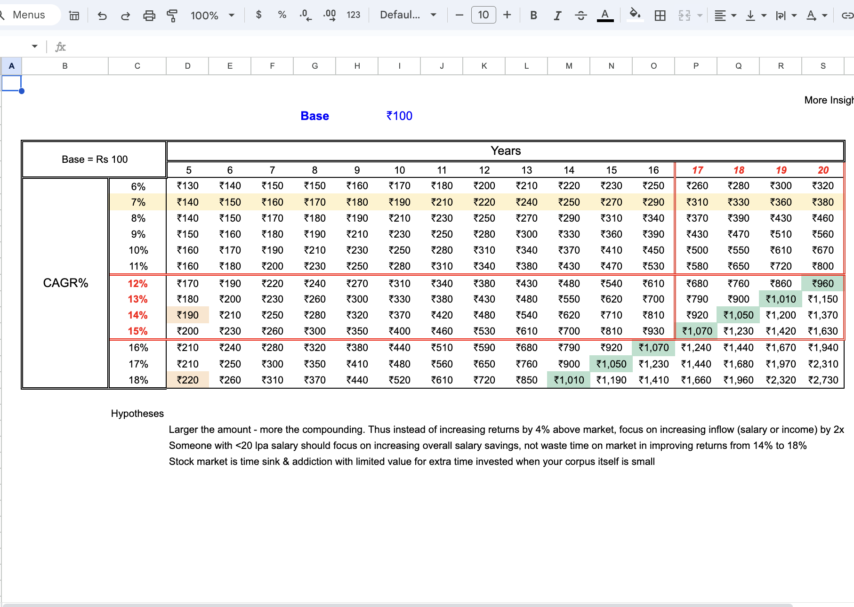](https://docs.google.com/spreadsheets/d/1t_cj5bR864sZRSRPTRZ7HhY6S55xGbi5HbjdWkCG8kw/edit?usp=drive_link)

#### 4.1.2 Minimalist retirement planning tool

When to use:

When you are looking for a minimalist retirement planning tool

How to use:  
Put in some numbers paying attention to the assumptions involved & then try 3 to 5 variations of each scenario trying to build an intuition of outcomes change

Please remember that these are nonlinear calculations so run a lot of variations to pick the right set simulations for your decision making

Click the image to go to the google sheet

[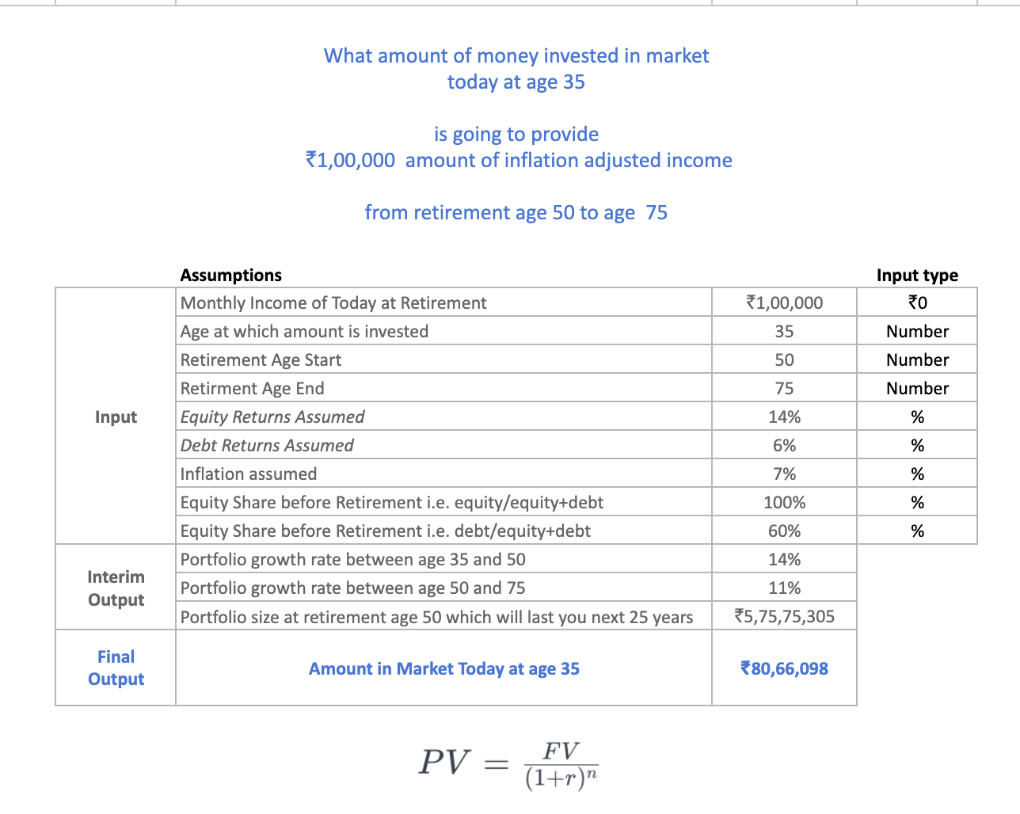](https://docs.google.com/spreadsheets/d/1xpC2bxEmcyWc93u_f_TDKEht2D2Vj1_gp8duI0eCT8Q/edit?usp=sharing)

### 4.2 How different financial instruments compound in India

#### 

#### 4.2.1 Endowment Policy vs FD/Debt Fund vs N50

When to use:

When you want to explain to your parents or someone else the long term pros & cons of different popular financial instruments in the ecosystem

How to use:

Start with simpler numbers say Rs 1k or Rs 1L to help the other person make sense of numbers, then slowly grow those numbers to the actual numbers you want them to look at, so they slowly build conviction on the calculation

Click the image to go to the google sheet

[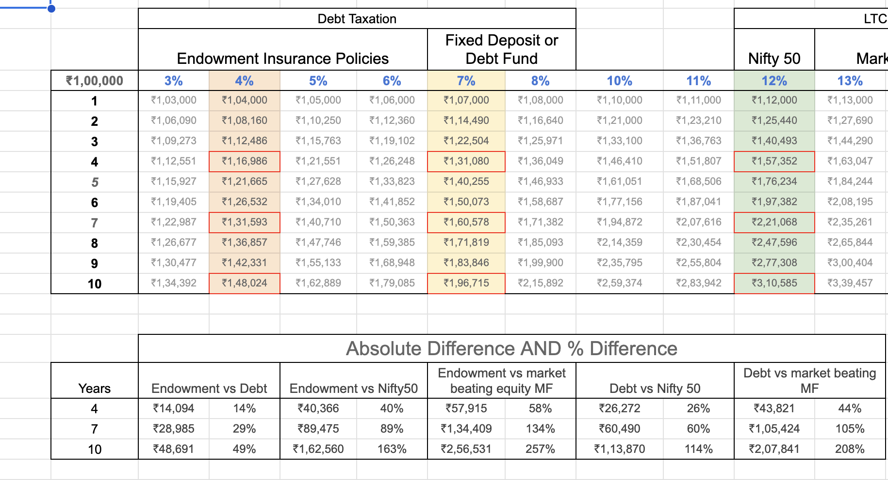](https://docs.google.com/spreadsheets/d/1yFmDOdM0E4hUIe6C0J0oCZrxIl-aO10ew-jeGeBorKY/edit?usp=drive_link)

#### 4.2.2 Nifty Index hands-on analysis 2010 to 2018

When to use:

When you want to understand different types of Nifty Indices in India

How to use:

This is a hands-on analysis built by me which helped me build an intuition for a few nifty indices beyond N50

Ideally you can copy this google sheet, learn the calculations, build an intuition & then go to the bookmarks mentioned to advance your understanding of nifty indices

I learnt this under the guidance of [twitter.com/paststat](http://twitter.com/paststat) & I highly recommend you to learn index analysis from him if you want to explore nifty indices for long term investing

I am not a Registered investment Advisor, so this is merely me sharing the analysis I did, please consult an RIA for such a sensitive decision making

Click the image to go to the google sheet

[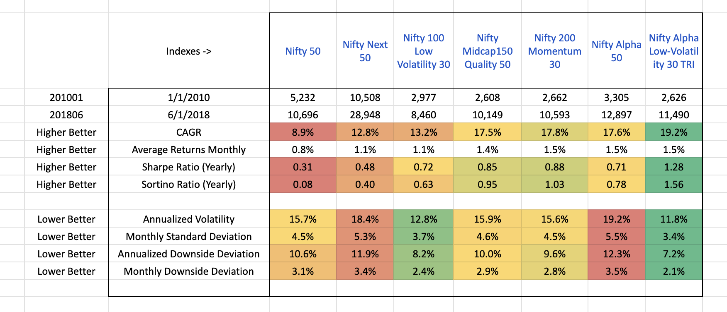](https://docs.google.com/spreadsheets/d/1wIuQOzfGcndbY72elrx3c8WT2LKVd0O25dE3pyVi4BU/edit?usp=drive_link)

### 4.3 How being good at math helps

#### 

#### 4.3.1 Learn math to be a better decision maker

When to use:

When you wonder how did learning mathematics in high school help anyone in their life in 20s & 30s

How to use:

This thread tries to use the patterns of high school math in real life decision making

Link: [Twitter Thread](https://twitter.com/amuldotexe/status/1501624056575311873/)

#### 4.3.2 Learn math to avoid -ve spirals

When to use:

When you wonder what is the opportunity cost of not learning math in the formative years

How to use:

This is perhaps the coolest anecdotal evidence I have collected on twitter in favor of math being an essential skill for the Indian ecosystem

Link: [Twitter thread](https://twitter.com/amuldotexe/status/1740654926512959768)

# 

# 

# 

# 

# 

# 

# 

# 

# 

# Section 02: Ebooks

## 

# 

# 

# 

# 

# Section 97: Bookmarks of amuldotexe

## Chapter 1: Tweets

## Chapter 2: Videos or Podcasts

## Chapter 3: Articles

## Chapter 4: Miscellaneous

### 

### 4.1 Notes of amuldotexe

* This playbook [amuldotexe.github.io](http://amuldotexe.github.io)
* My tweets in a google sheet : [Tweets 202404](https://docs.google.com/spreadsheets/d/1P8qbGbhW_KnYNDyaC-7mJkmx9-h93irmCmHXDaLkMm4/edit?usp=sharing)

# 

# Section 98: Weekly Journals

# Section 99: What next

## 99.1 Playbook release cadence

This playbook is totally free

you are free to

* copy it to your google drive
* share text or screenshots from it

I hope you

* experiment with these methods & benefit from them
* if you do vibe , just drop me a note on twitter [using this link](https://twitter.com/messages/compose?recipient_id=1132151165410455552&text=Hello%20world)
* If you do not agree with me, still drop me a note on twitter [using this link](https://twitter.com/messages/compose?recipient_id=1132151165410455552&text=Hello%20world), btw this link works irrespective of whether you are premium subscriber or not

I will keep updating this url [amuldotexe.github.io](http://amuldotexe.github.io) with the latest playbook every 2 weeks

I have more than 45 thousand tweets in last few years, so a lot of my notes are yet to be summarized, this is just the beginning

If you want to receive bi-weekly email updates of the release with notes on additions etc. then please [use this link to buy it for $0 / free on gumroad](https://amuldotexe.gumroad.com/l/playbook)

the gumroad page helps me

* collect email ids with explicit consent to receive updates
* send mass emails to folks (I learnt you can’t do that with personal ids)
* build *some* public reputation in form of downloads, stars & reviews, for e.g. the current metrics for v1 are
  + ~2000 downloads
  + 100+ five stars

## 99.2 Topics for next release

**Bookmarks of amuldotexe**

* fav creators to read & why
* fav decks & excels
* fav tweets as hyperlinks
* fav video links

**Content Consumption**

* Unhelpful patterns from movies
* Nuanced wisdom from movies
* Beware of storytellers
* Truth is stranger than fiction

**Subconscious programming**

* Affirmations
* All-or-nothing thinking
* Peace Mode vs War Mode

**Coding**

* DSA Intuition
* Rust revision list questions
* Prompts for learning Rust
* Prompts for learning DSA

**The physics of humans**

* Borrowed conviction vs Built conviction
* Spectrum thinking
* Principal Agent problems

**Meta Patterns**

* Wisdom of linear equations
* Minimum effective Dose
* Context is everything

**Dumbledore’s man through & through**

* Low drama writing
* Low drama talking
* Being predictable

**Reminders for Techies in India**

* Weekly reminders
* Monthly reminders
* Quarterly reminders
* Yearly reminders

**Journal & Collaboration**

* PM to dev journey
* Bottom 10 percentile ideas
* Communities I run